Pinball League: Hardhat Zone for Windows 8.1
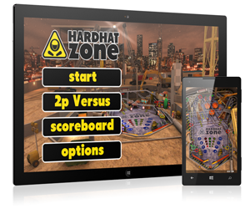
If you already own Hardhat Zone on the Phone you can get it today on your Desktop or Tablet for free!
Hardhat Zone is now a Universal App, available on both Windows Phone and Windows 8.1.
“Hardhat Zone” is our new, immersive, “construction site” themed pinball table. A world full of activity, machinery and workers, cranes and bulldozers. Unlock and complete all the stackable modes, collect the bonuses and rack up your score.

But bragging about your high-score to your friends on Facebook just won’t cut it anymore! Challenge your friends to a simultaneous 2 player Versus match: bump together your NFC equipped devices and connect instantly for a competitive 2 player game! Gain bonuses for yourself and send obstacles to your opponent!
- Photorealistic graphics
- Arcade mayhem
- Refined ball physics
- Vibration feedback
- Tilt mechanics
- Portrait and landscape modes
- 2 player NFC showdown…
…welcome to the Hardhat Zone!
http://www.windowsphone.com/s?appid=6e5d76ca-85d8-4f87-bf96-0840214d03dc
http://apps.microsoft.com/windows/app/pinball-league-hardhat-zone/084daf06-5b6a-4c86-98d7-e6edec202bc6
tainicom
“tainicom” is an indie studio focusing primary on mobile games and applications. It was founded in 2010 by two Greek developers with many years of experience and a passion for classic gaming values.

tainicom LTD
Athens Greece, November 13, 2014

